September 22.
Assessing the bins for our Action plan.
Checking to see if waste has been distributed correctly.
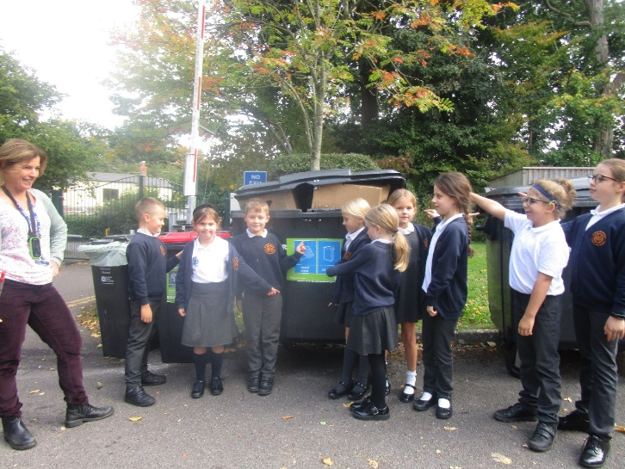
September 22
The Food waste at playtimes are going in the general waste.
We need to transfer food waste from the playground to the large compostable food bin.
We need to order two brown food bins for the playground.

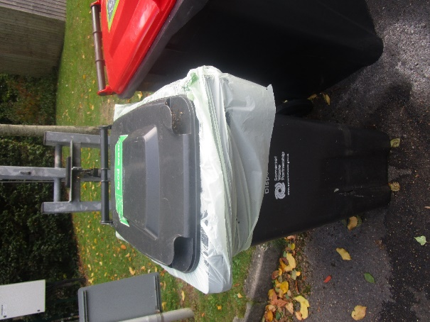

October 22
Evidence of food waste going into the general playground bins. The Eco warriors cleared the bins out and sorted into the brown compost bins. This was a messy job.
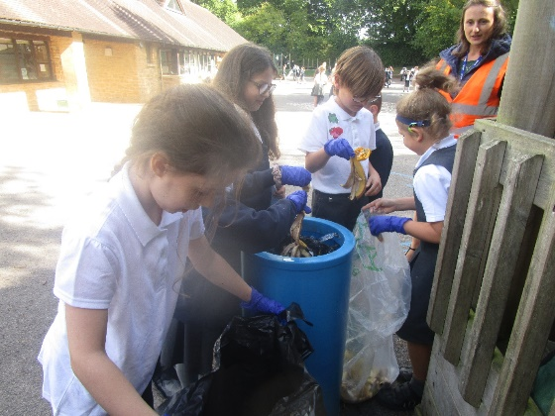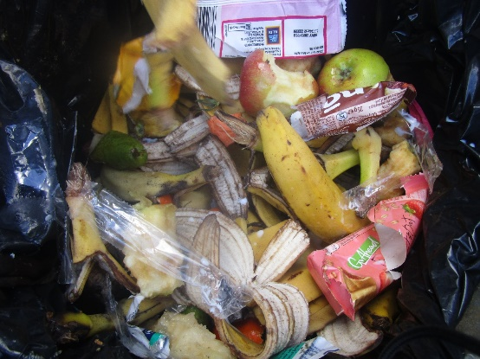
March 23
Playground bins are not being emptied enough, resulting in squirrels and birds getting into the rubbish and litter blowing about the playground. Children are still not putting rubbish into the correct bin. We are also concerned about the amount of unhealthy snacks found in the bins.
Time to launch waste free Wednesday.



